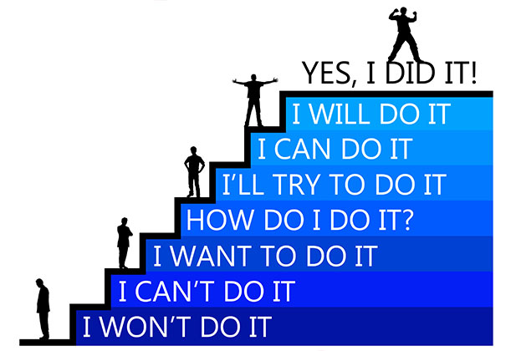

Self-Esteem & Confidence Building

6 week Programme

**To develop healthy self-esteem and to build confidence** in the process of self-understanding, self-acceptance, self-confidence and resilience.

Please check with local Multi-Disciplinary Team at your GP Practice for referral

Or

Contact Gemma on 028 4461 2311

**Where**

Newcastle Centre, Promenade Newcastle

**Starting**

Tuesday 21st April 2020

Session will run 14.00-16.00

